Payroll Management System for Information Technology Company

Use-Case Specification: View User Salary Project

Version 1.0

Revision History

|  |  |  |  |
| --- | --- | --- | --- |
| **Date** | **Version** | **Description** | **Author** |
| 17/12/2019 | 1.0 | Final | Quản Trọng Tú |
|  |  |  |  |
|  |  |  |  |
|  |  |  |  |

Table of Contents

1. Use-Case Name 4

1.1 Brief Description 4

1.2 Actor 4

1.3 Flow of Events 4

1.4 Basic Flow 4

1.5 Alternative Flows 4

2. Special Requirements 5

3. Preconditions 5

4. Postconditions 5

5. Extension Points 5

Use-Case Specification: View User Salary Project

# Use-Case Name

## Brief Description

This use case defines the step of viewing all user’s salary in project. Administrator can easily view all user’s salary to manage the payroll system.

## Actor

Administrator

## Flow of Events

## Basic Flow

Administrator click View button to show all project information. If it is null it will show message and if it is empty, table won’t display anything.

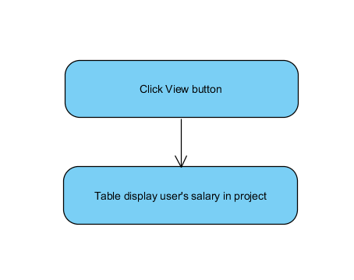

Basic flow of viewing user salary project

## Alternative Flows

Administrator can view user’s salary in project by search specific project by project id.

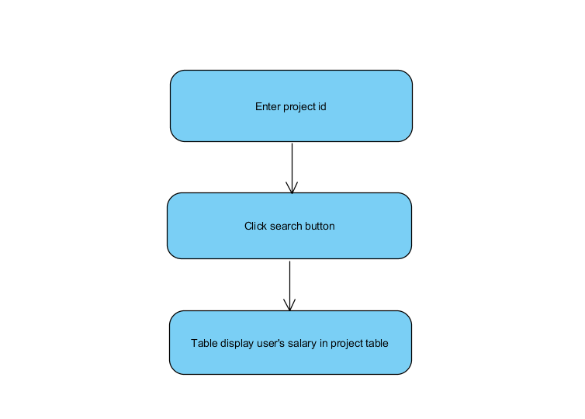

# Special Requirements

No special requirements.

# Preconditions

* Admin have to login into this application and access Manage Project view.

# Postconditions

No post conditions.

# Extension Points

No extension points.